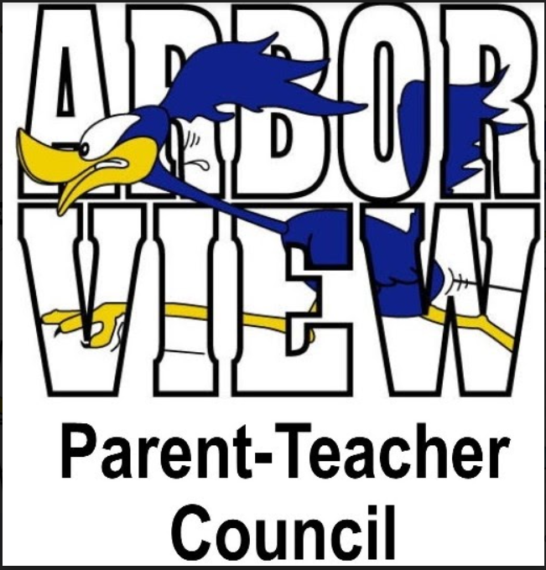

Agenda
March 8, 2022

- Call to Order – Called to order, 7:03pm
- Approval of Minutes – Minutes approved, 7:04pm
- President’s Report – Stephanie Furlong
  - Independent audit of CCSD89 was conducted, and all went well
  - Financial survey results voted on overall maintenance for all 5 buildings
    - Bond referendum June 28th to vote
  - Snow days: There were mixed feelings about snow days vs eLearning days. Please reach out to Mrs. Burnett or one of our PTC members if you have any questions, concerns, or feedback in the future
- Treasurer’s Report – Stacy Moskos
  - Several incoming checks this month
    - $15 Restaurant Night from December
    - $123 from Box Tops
    - $104 for Chicago Wolves night out
- Principal’s Report – Mrs. Burnett
  - IAR for 3 – 5th grade are the next 2 weeks, Math and ELA
  - Variety Show practices have been going strong, and we’re excited about it
  - Fun Run: Had call with organizers last week
    - April 22nd is date of the fun run, but kick-off activities start April 12th
    - Mrs. Burnett to discuss with teachers soon, more info coming
  - Spring Break reading logs for students to earn Kane County Cougar tickets
  - Yearbooks! Spread the word and order through MySchoolBucks. Deadline to order is Spring Break
    - Club pictures on Friday
  - Great experience with Chicago Bears player last week. Students and staff were so excited
  - Teachers and staff are energized and excited for upcoming events and the rest of the school year!
- Faculty Report – Mrs. Carlson & Ms. Clarey
  - Teachers are working hard to get through the next few weeks before spring break!
  - Students are looking forward to the Book Fair and St. Patrick’s Day activities next week
- Committee Report
  - Art Smart
    - Numbers are ~70 kids per month
    - Next month is a parent spotlight (Lisa Loftsgaarden)
    - Let Miya know if any parents are artists and would want to participate
    - Miss Clarey knows of a second grade parent who is an artist

- Liaison Report
- Cub Scouts
  - Scouts will be doing Scouting for Food this weekend, dropping off bags in the Valley to fill with food for the food bank. Scouts will be picking up the filled bags to donate next week
- BoosterThon
  - Brad Hemesath meeting with contact soon for kickoff
  - Fundraising, themes on leadership and character building, with fun run at the end of the week
  - Brad will fill out form on PTC website to announce – please reach out if you want to help! (SignUp Genius could be a suggestion to get volunteers)
  - Mathnasium reached out to donate goods. Stephanie/Brad to reach out. Lisa to share owner from McDonalds, who always donates, as well as gas station at the corner
  - Share past corporate/businesses that have donated previously (Christine/Kim to check Google Drive and share with Brad)
- Scouts – Girl Scouts - Olivia Loftsgaarden
  - 1st grade Daisies built food kits for the GE Food Pantry. They are donating some of their cookie funds to St. Jude’s and the alliance to stop homelessness
  - 2nd grade Brownies went show-showing to earn their snow adventure badge. They are working toward their painting badge, and have attended many museums for inspiration. They will be selling cookies at the Walgreens on Naperville Road in Wheaton, on Friday, March 11 from 4-6
    - 2nd graders will be painting a large sign, any ideas what they can do? Girls on Fire, Teacher Appreciation, BoosterThon, 5th grade farewell
  - 4th grade troop have sold over 3,800 boxes of cookies. They have been busy earning their badges
  - 5th grade troop is working on their social butterfly badge, and are also wrapping up cookie sales

- Old Business
- N/A

- New Business
- Reminder: Variety Show is back- March 23 @ Glen Crest
  - Rehearsals are underway. Come support and see a wonderful show on March 23rd!
  - Keri Poi to share information on tickets, how to attend, etc, since many families have not attended an in-person variety show
- Book Fair - Stephanie Furlong
  - March 15th and 16th. During school on Tuesday, students will preview during the day. Wednesday will be a shopping day during school
  - Every student is able to choose a free book (up to $5). Students can also donate their book to their classroom or the library
  - Family shopping is Wednesday night from 5-7pm
  - Volunteers are still needed to help during the day or at night. Please see Mrs. Burnett’s newsletter or reach out to Stephanie Furlong to volunteer
  - K and 1st grade students will be taking pictures with their iPads as their “wish list” rather than filling out handwritten wish list
- BINGO – No updates as of now. Look at dates later this spring or possibly the fall
- 2022-23 PTC Board Nominations
  - If you are interested in being on the Arbor View PTC board, please reach out to Sarah Malcolm with your name and position interested in
  - Voting will take place in April, and new board will be shared at PTC meeting in May
- Teacher Appreciation Days
  - Luncheon will be after school half-day, April 14th
  - More information from Andrea Lichtenheld
- Girls on Fire starts next week
  - Tuesdays and Thursdays for 90 minutes
  - Social skills, workout, running a 5K at the end of May
  - Please reach out to Miss Clarey for more info – there are 9 spots left!

- Comments

- Adjournment – 7:47pm

